***Table Creation:***

**Admin Table:**

create table Admin (Admin_id number (10) , Admin_name varchar2(20), Admin_phone number(10));

alter table Admin add constraint aw primary key (Admin_id)

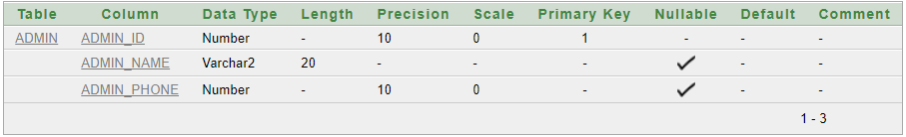

**Customer Table:**

create table customer (c_id number (10), c_name varchar2(20), payment number(10), c_phone number(10));

alter table customer add constraint bw primary key (c_id)

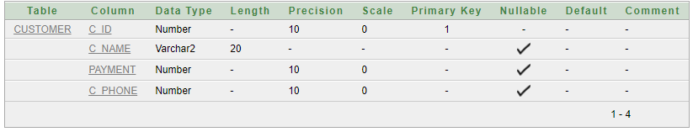

**Payment Table:**

create table payment (p_id number(10), record varchar2(20), cash varchar2(20), credit varchar2(20));

alter table payment add constraint cw primary key (p_id)

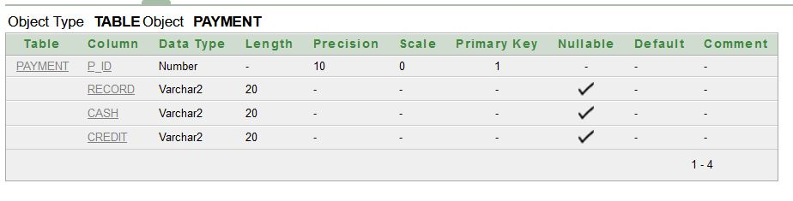

**Service Table:**

create table service( Service_no number(10)primary key, Pedicure varchar2(20), Manicure varchar2(20), Facial varchar2(20), Massage varchar2(20), Fees varchar2(20), Threading varchar2(20), Waxing varchar2(20));

alter table service add constraint dw primary key(service_no)

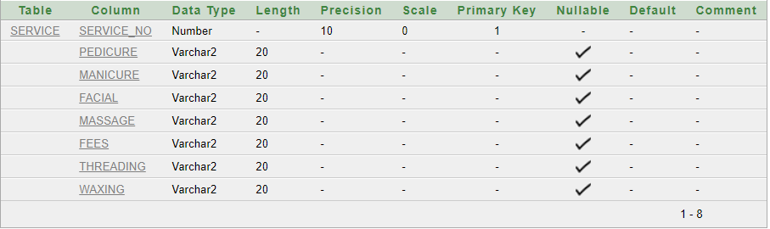

**Beauty Parlor Table:**

create table beautyparlor(code_no number(10), Appointments varchar2(20), payment_records number(10), Employees_availability varchar2(20));

alter table beautyparlor add constraint ew primary key (code_no)

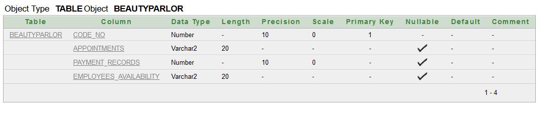

**Employees Table:**

create table employees(e_id number(10), e_name varchar2(20), worktime number(10), E_address varchar2(20), salary number(10), E_phone number(10), profession varchar2(20));

alter table employees add constraint fw primary key (e_id)

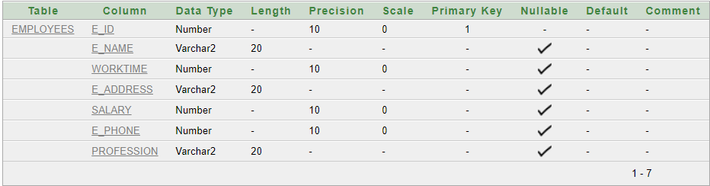

***Value Insertion:***

**Admin Table:**

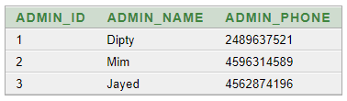

**Customer Table:**

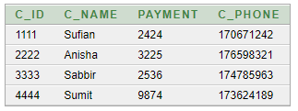

**Payment Table:**

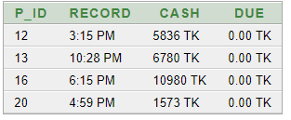

**Service Table:**

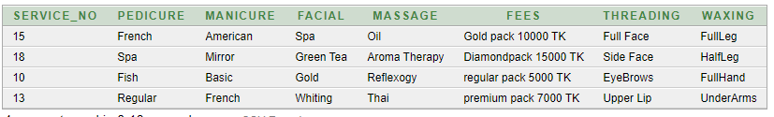

**Beauty parlor Table:**

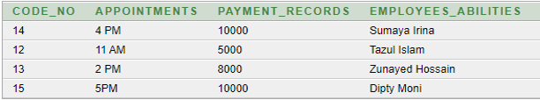

**Employees Table:**

